CSTR Process Controller

Course: ECHM 44

Date: April 30, 2015

Author: Thomas Thelen

**Introduction**

Control systems have been used for over 400 years, playing integral roles in automated systems. With the increased resources on the topic and access to computation, engineers have been able to apply the field to industrial processes.[]

**Experiment**

The temperature of a CSTR housing an exothermic reaction was controlled by implementing a proportional-integral controller. A cooling jacket was used as the heat sink. The controller was used to calculate the temperature at which the cold fluid should be to adequately cool the reactor.

The system was described by thee coupled differential equations describing the product concentration, the reactor and sensor temperatures, and the requested cooling water temperature. The ODIENT library, part of BOOST, was used to solve the system by using the classical Runge-Kutta method.

The velocity form of the basic PI algorithm, shown below, was used for its computational simplicity.

$∆CO\left(t\right)=k_{c}[E_{i}-E_{i-1}+\frac{∆t}{τ_{i}}$] [1] (1)

The controller gain, $k_{c}$, acted as an amplifier for the controller output which, when too large will cause the system to oscillate. The integral time constant, $τ_{i}$, which allows for faster response times.

**Results**

Without any tuning, the controller gave a divergent oscillatory response centered on the set point. Because this can lead to dangerous consequences, the controller was field tuned. The classical field tuning method was used to determine the process tuning constants. This improved the controller response and decreased the overall error.

Table 1 Process control constants found from field tuning.

|  |  |
| --- | --- |
| Variable | Tuned |
| $$k_{c}$$ | 120 |
| $$τ_{i}$$ | 0.1 |

The high process gain caused the system to overestimate the cooling temperature, contributing to the first positive temperature spike, seen in Figure 1. The integral time constant was low, also effecting controller output by giving it tighter control. The oscillations are artifacts from the field tuning method.

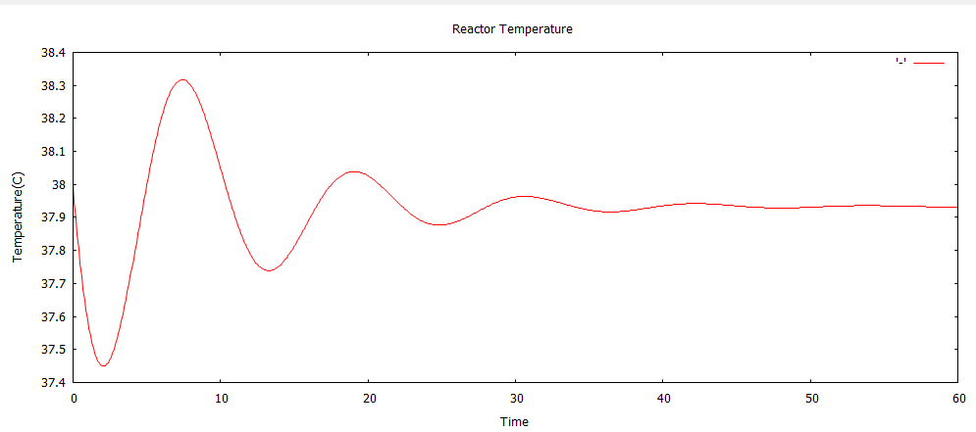

Figure 1 The temperature profile of the reactor. It reaches steady state as the concention .

The temperature had the greatest error during the first ten minutes of operation. After, the temperature trend followed that of the cooling water, shown in Figure 2. The temperature had a maximum temperature error of $5℃$ and reached steady state around 35 minutes. The controller also let the temperature exceed the set point which may be unsafe.

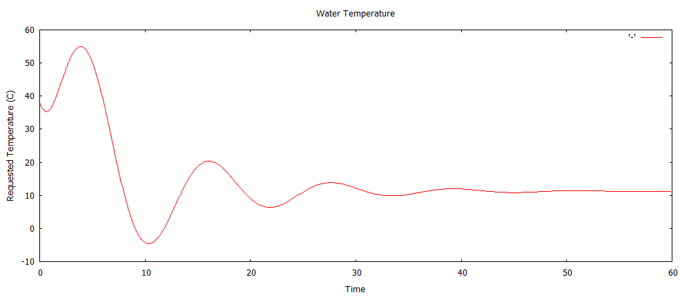

Figure 2 The requested water temperature leveled off as the temperature reached steady state.

The water temperature needed for steady state operation was approximately 11 $℃$. After ten minutes, the requested temperature drops below the freezing point of water, presenting a piping problem. The temperature reached an almost constant value at the same time the temperature leveled off.

**What-If Analysis**

The system was further explored by simulating a surge of cooling water. This could be possible by manually opening the cooling water valve in the case of overheating. To simulate the increased flow rate, the residence time, $τ_{T}$, was decreased to 1.0.

New controller constants were calculated and compared to the non-surge-system.

Table 2 Process constants after the cooling jacket time constant was modified.

|  |  |
| --- | --- |
| Variable | Tuned |
| $$k_{c}$$ | 30.0 |
| $$τ_{i}$$ | 0.5 |

Because $k_{c}$ is smaller and $τ_{i}$ is greater than before, this control scheme gives more lose control. Because energy can be dissipated faster, the system does not need the tight control as in the original CSTR.

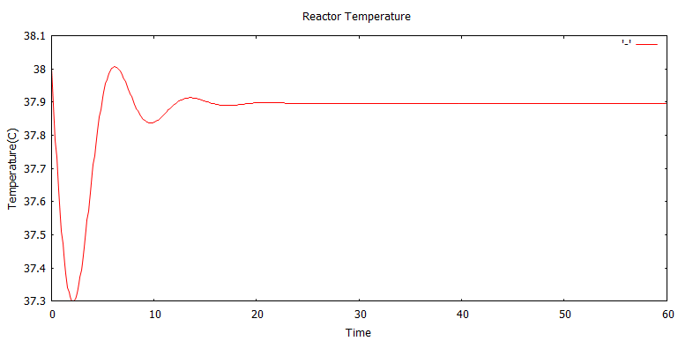

Figure 3

From Figure 4, it is evident that the decreased residence time effected the temperature by undershooting the set point by $7℃$. The larger temperature error is most likely due to the system having more relaxed parameters than before. The temperature also did not exceed the set point.

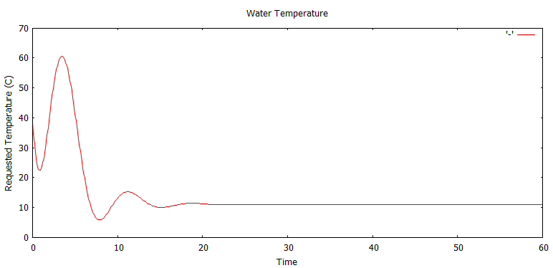

Figure 4 The requested water temperature experienced a larger fluctuation.

The requested water temperature was also effected by the change, shown in Figure 4. The water temperature was requested at a higher temperature, due to the decreased contact time.

**Closing Remarks**

At steady state, the controller will keep the reactor temperature within $± ℃$. The large oscillatory response may be eliminated by exploring other tuning methods such as the Cohen-Coon method.

Works Cited

http://ieeecss.org/CSM/library/1996/june1996/02-HistoryofAutoCtrl.pdf

http://www.facstaff.bucknell.edu/mastascu/econtrolhtml/Intro/Intro1.html